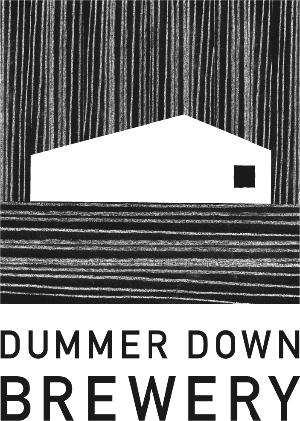
Taproom Bar Staff Wanted
Dummer Down Brewery is looking for friendly, enthusiastic Bar Staff to join our brewery taproom team. This is a customer-facing role in a relaxed but busy taproom environment, serving our own beer alongside guest beers and creating a welcoming atmosphere for visitors.
The Role
- Pouring pints and serving other drinks from our menu
- Talking to customers about our beers and making recommendations
- Taking orders and handling payments
- Keeping the bar, cellar, and taproom clean and organised
- Helping with set-up and close-down of the taproom
- Supporting events, busy weekends, and brewery open days
About You
- Friendly, confident, and good with people
- Reliable and punctual
- Interested in beer and independent breweries is a bonus but not essential (training provided)
- Comfortable working in a busy, hands-on environment
- Previous bar or hospitality experience is useful but not essential
What We Offer
- Competitive hourly pay
- Training on our beers and brewery processes
- A supportive, informal team environment
- Flexible or regular weekend shift
- Free meal on shift
Availability and hours
Regular taproom hours:
- Friday 4 - 10pm
- Saturday 4 - 10pm
- Sunday 12 - 5pm
During events, you may be required to work slightly longer shifts (typically an additional 1–2 hours).
If interested please contact ben@dummerdownbrewery.co.uk

